Aim
This module aims to place issues for international students in context by exploring the student lifecycle from pre-entry to exit.

Objectives
By the end of this module you will:
- understand the international student lifecycle and points of engagement/disengagement;
- identified what issues may arise within each and across the four areas; and
- problem solved practical problems for international students.

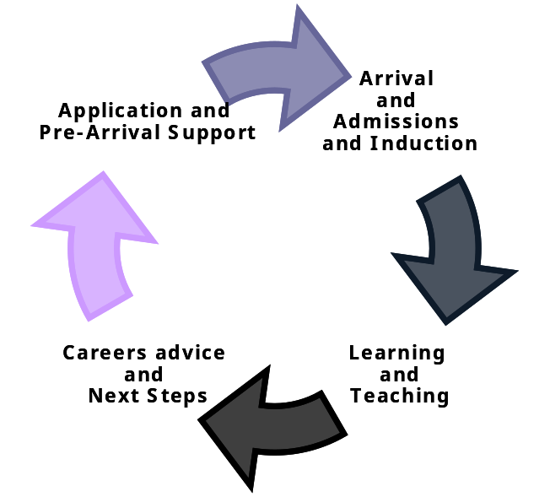
The Student Lifecycle

Notes

W Curve: Stages of Cross-Cultural Adjustment

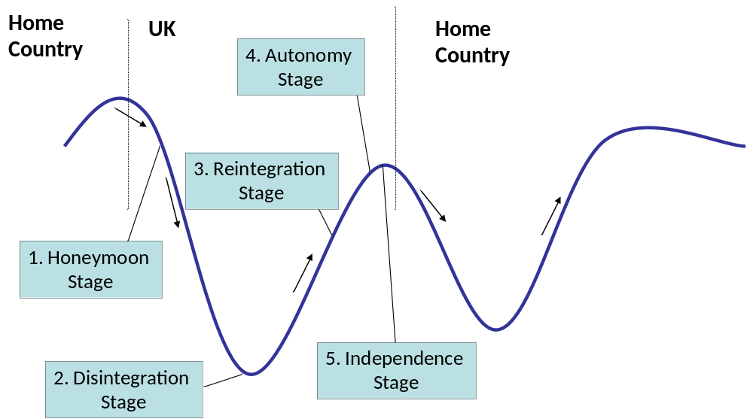
Reference: Adler (1975)
“The Transitional Experience, an alternative view of culture shock”,
Journal of Humanistic Psychology Vol 15 No 4, pp13 - 23

Notes


W curve: Stages of Cross-cultural Adjustment
Stages | Perceptions | Range of Emotions | Behaviour | Interpretations
1. Contact/ Honeymoon | Differences are interesting and intriguing  How the new culture is viewed may be selective – looking only at the positive and exciting parts. | Excitement, stimulation, euphoria, playfulness, discovery. | Curiosity, interest, assured, impressionistic. | Individual is protected by his/her own culture.  Differences as well as similarities provide reason for being themselves in a new country and feeling sure of their own identity and how they fit in.
2. Disintegration | Differences create an impact and have and effect on day to day living.  Can see good and bad aspects of the new culture. | Confusion, disorientation, loss, apathy, isolation, loneliness, inadequacy. | Depressed, withdrawn. | Cultural differences start to have an impact on confidence and self-esteem. Do not feel part of the new culture, classes or groups. Homesickness and missing family and friends who understand their culture and provide support. May find it difficult to understand and communicate ideas.
3. Re-integration | Differences are rejected. | Anger, rage, nervousness, anxiety, frustration. | Rebellion, suspicion, rejection, hostility, opinionated. | During this stage people will start to reassert their own personality, pride in their own culture. This is positive as is signals a growth in confidence and self-esteem although students can be come focused on the negative aspects of the society and culture they are living in.
4. Autonomy | Differences and similarities are legitimised. | Self-assured, relaxed, warmth, empathy. | Assured, controlled, independent, “old hat”, confident. | Student is able to communicate effectively in new situations. They are no longer anxious about interacting as are self-assured they can cope and succeed.
5. Independence | Differences and similarities are valued and significant. | Trust, humour, love, full range of previous emotions. | Expressive, creative, actualising. | Social, psychological and cultural differences are accepted and enjoyed. Individual capable of exercising choice and responsibility.

Issues and Barriers to Engagement

International Students will often have the same issues as students here but will feel them more intensely due to distance from networks of family/friends cultural differences and, for some, language barriers. The list below highlights some of the issues that international students may face.

- Cultural Differences – It’s difficult enough moving away from home for the first time to study but imagine moving to a whole new country at the same time. Everything from the food to the traffic systems are different here. Don’t forget that students that speak English will find it difficult too. There may be issues with faith and customs – it is important to be sensitive to student needs and offer a variety of activities.

- Accommodation – this may not be as expected when students arrive, they may not have all they need in terms of bedding etc, some students turn up to find out their accommodation is not ready. Think about how difficult has it been for them to organise accommodation from a distance, accommodation arranged without viewing could be poor quality/high cost – international students could need support to complain to landlords/letting agents.

- Visas and immigration – Constantly changing systems and rules, reapplying for visas can be complex and small mistakes can result in forms being returned, expenses incurred applying for visas, stress while waiting or when rejected, timescales for visas can be difficult, issues if a students needs more time to re-sit examinations.

- Finance and banking – it can be difficult for international students to set up bank accounts, do they have the correct information with them, what impact does a language barrier have, what kind of bank account can they get, how can they access funds from home without a bank account? There could be additional stresses involving expectations and tuition fees. What information had they received pre-arrival on how much they would need to live on – sometimes they are not prepared for the living costs here. Restricted working hours mean they have less capacity to earn money.

- Counselling/healthcare – International students will not be familiar with our healthcare systems, if they require prescriptions the medication here could have a different name and could be confusing, issues with stigma of disabilities/mental health in home countries may mean they find it intimidating or difficult to engage with health services, language barriers can compound discussing complex medical issues, isolation can lead to depression.

- Academic support – Cultural differences in academic engagement, different teaching styles and expectations of support, poor communication of plagiarism, lack of engagement with class rep systems and poor representation, language barriers, attitudes of teaching staff and/or other students, issues with group work and integration, resists and visa issues.

Barriers to Engagement

International Students may be less likely to engage because of increased stress, cultural differences, academic stress/pressures, language barriers and isolation. They may be unaware of how the Union operates as it may be different in their home country, there may be issues engaging those who come from non-democratic countries with democratic structures. If they have faced discrimination they may have concerns about engaging with a union that have a low number of international students already engaged.
Case Study Exercise – Letters for the British Council Shine! Competition

Letters reproduced with kind permission of the British Council and competition winners.

In your groups consider the case studies and work through them identifying the cultural, social and academic issues in each case study in your workbooks.

Which part of the Student Lifecycle and the Stages of Cross-Cultural Adjustment do you think these issues fit into?

Letter 1
Dear Mama,

I cannot believe that I will become a doctor in July! It's been almost 5 years since I set foot here. Words cannot describe how much I have bloomed into a lady from a timid young girl. I think studying here in a culture that facilitates growth has enabled me to achieve so much in so many ways.

Mama, as you know I aspire to become an academic clinician. I am grateful that there are many opportunities here to pursue academia alongside clinical medicine. As we could not afford to fund my intercalated degree, I have tried to compensate for that by applying to numerous studentships. My efforts paid off when I was offered a studentship by the Anaesthetic Research Society last summer. I worked on a lab at the Institute of Medical Sciences for 8 weeks conducting experiments on new compounds that may save thousands of septic patients in the future. Although the studentship has ended, I volunteered to continue the work doing term-time as I believe that the knowledge gained may revolutionize the way we treat patients.

Remember the paper I wrote about medieval Islamic medicine? The abstract was accepted and I presented it at the inaugural National Student Medical Humanities Conference! It was well received by the audience and I am so pleased to have my work appreciated by the wider medical community.

After my studentship ended I went on my neuroscience elective to Canada. You advised me to forego that as the huge planning and financial strain would put a lot of pressure during my penultimate year. It was no walk in the park, Mama, to realize my dream. However, because I managed to demonstrate my passion and determination, I was awarded bursaries by the Medical Women's Federation (MWF) and the Enid Linder Foundation to finance my elective project. All my sweat was sweetly rewarded by an amazing 2 months at the Centre for Brain and Mind where I performed experiments to understand how the visuomotor system works. The MWF was so pleased with my elective report that they have invited me to speak at their annual general meeting this February.

Don't worry that I have been focusing on academia too much, Mama. I still am enjoying my artistic pursuits. Immersed in the legacy of Robert Burns, I have been dabbling in poetry. Much to my surprise my poem won the prestigious triennialy awarded Calder Prize in poetry. The poem must have struck a sentimental chord in the judges, Mama, as it was inspired by you.

Speaking of languages and literature, I enrolled in French night classes as I have always been fascinated about that most romantic of languages. I now can get by in a francophone country with my level of French. Not only that, I took Spanish for our Medical Humanities course and won a prize for earning the highest distinction. Having basic knowledge of Spanish really helped me gain the trust of some Spanish patients here we have at the hospital. They were grateful that I made an effort to communicate with them in their mother tongue.

It is hard being in Scotland and not be enchanted by its music. I was so drawn to Scottish music that I joined a university fiddle ensemble. My fiddle and piano playing have improved so much since. I felt that it was time to do something beneficial with my musical talent so I joined my band for a tour in Northern Ireland to raise funds for the Northern Ireland hospice. I also helped to organise and perform at a charity concert to raise awareness about sexually transmitted diseases and fundraise for the Terence Higgins Trust. Performing cover versions of contemporary songs with lyrics about the dangers of STD (with 'feeling')was quite embarrassing at first but in the end, people had a good laugh and a good time. We raised quite a lot too!

At this stage, I feel very happy to have developed so many skills and achieved numerous things within my time in the UK. I am thankful to be living in an environment where anything is possible and the sky is the limit. You and dad have taught me well i.e. to believe in myself and just go for it. I await my graduation with much anticipation, as I celebrate a momentous occasion with whom I hold dear. I love you, Mama.

Your loving daughter

P.s. Speaking of skies, I did my first solo skydive when I was in Canada! =)

Cultural Issues

Social Issues

Academic Issues

Student Lifecycle Stage

Cross Cultural Adjustment Stage

Letter 2
Dear Shine,

I sat down to write this letter and I wondered how to describe the change that I have gone through since I arrived in the UK three years ago for my PhD. I'm not transformed or genuinely changed, I'm not a new person, I'm rather the same old person that I used to be, I'm only a more optimistic one. The people hurrying back home in the snow outside my window is the best example of my case. It may be difficult, inconvenient, and extremely annoying to venture among small, cold snowflakes rushing toward them, and walk over slippery side roads, yet, people outside are not really letting the snow deter them from getting on their everyday business, they go out anyways, armed with warm and elegant outfits, umbrellas just in case it rained, heavy boots for added stability and some songs and music for the road. It's true that there are risks in such weather, a storm may blow, someone may slip and break a bone, the bus may never arrive, someone may get sick, or else, these are all calculated risks, you can equip yourself by checking the weather more frequently, getting proper shoes, know which road to take and which road to avoid, prepare a plan B in case the bus didn't show up… I'm more of an expert by now in all such activities, I learned my lessons by trials and errors, I can get a pretty good picture of how safe a snow-covered side road is by just looking at the texture of the snow or by observing the behaviour of people walking along that road. These challenges in meeting everyday goals are what make up my life as a woman back home, I used to go through all those extra measures, many times unsuccessfully to meet the demands of being a pharmacist with three children and a difficult career to look after in a man-made world, literally! In Saudi Arabia, many things were beyond my capacity and/ or potentials are being put to real life test here in UK.

Some of such things, are just simple things that may never cross anyone's mind elsewhere, were beyond my reach, like driving my car, attending a musical with my daughters or walking them to their school, skiing with my son in winter, window shopping in Christmas, joining my colleagues on short trips to showcase our research findings in UK and abroad, standing beside my posters in a hall full of scientists and getting enough attention to keep me content that I'm on the right path in finding better ways to treat cancer. Academically, on June 2009 I was awarded the Biomedical, Chemistry and Drug delivery group (BCDD) Research Day Prize for the Second year PhD students in University of Strathclyde. Luckily, on the same month I was also awarded the Prize for outstanding poster at the 3rd Saudi International Conference (Surrey). On 2010, I participated in the Controlled Release Society (CRS) symposium (USA) with a poster. I was contacted by the CRS Newsletter Editor to feature my work in the CRS Newsletter, which was published as the cover issue. On the same year, I won the Research Excellence Award from University of Strathclyde. Being a Saudi female student in UK, I participated in the activities organized by the Saudi clubs in UK. I was a speaker at the First Academic Forum for Saudi Female Students in the UK and Ireland (Sheffield, 2010). I talked about my joyful experience as a Saudi mother & student abroad and the value of being exposed to a different culture. On the Saudi Day Exhibition in Glasgow (2010), I was the main female speaker who explains the Saudi women education to the official groups and publics...I'm not taking my new assets for granted. Blesses like these are possible in my country but just like snow, they would take ages to achieve, and sometimes, would never materialize because of a simple obstacle that wasn't foreseen.

I'm not the woman who preferred safety over challenges like I used to be, I learned that from a successful PhD experience that has started three years ago. For just like these people outside in the snow, I can take planned risks, I can cross the borders and travel to lengths outside my warm and comfort to reach a goal worthy of a challenge. I can walk the slippery, uncertain path safely if I used the proper tools, and I can accept that not all my trials would end successfully because of an unexpected storm, but I would always feel content that I did all I can to achieve my destination even if a storm interrupted my journey. Now that I'm wrapping up the writings of my PhD dissertation, I'm closing up a chapter on a journey that has started three years ago, exactly the same duration of time it took me back home to finish my master, the road was hard back and now, yet it appeared more clear and well equipped this time than it did before, and I'm almost reaching the destination faster and better. The change wasn't really in me, it was in the tools that I was offered here, the correct road map and the proper guidance that I have received here; they shortened the distance and kept me warm enough to venture confidently in the snow..

Cultural Issues

Social Issues

Academic Issues

Student Lifecycle Stage

Cross Cultural Adjustment Stage

Letter 3
Dear Dad,

Kindly accept my heartfelt greetings. I hope you, mum and my siblings are doing great.
My time so far in the UK has been an interesting and rewarding one. I was thinking that the willingness of lecturers to teach and devote time to help students would end at the master's level, but I got it wrong. At the start of my PhD following the successful completion of my MSc program at the same institution, I was in a fix with so many research ideas in my head. With the guidance of my supervisory team, I was able to narrow down my ideas to something original and researchable.
Dad, I am delighted to let you know that I have won a number of awards and recognitions since coming to the UK. I emerged the best student at the end of my MSc in Energy and Environmental Management in 2008 and won the VALPAK prize. In the same year, I won the Igala UK distinguished academic scholar's award sponsored by our ethnic group in the UK here.

In January 2010, I won another award as one of the 30 most outstanding black students in Britain and the only one from Scotland. Please see details at:
http://www.gcu.ac.uk/newsevents/news/bydate/2010/2/name,8872,en.html

Still in 2010, I had a dinner with the Mayor of London Mr Boris Johnson and High Commissioners from several African countries at the invitation of the Mayor to celebrate the 50th anniversary of some African nations. It accorded me an opportunity for networking with personalities I only normally see on television while in Africa. The usual overzealous security details and aides who made it difficult for citizens with genuine missions to access government officials in our country were absent. These awards and recognition are dedicated to you and mum for teaching me to always aim for the best.

Outside my studies, I volunteered with the British Trust for Conservation Volunteers during my MSc. We promoted environmentally friendly behaviours in the face of climate change threats. Other voluntary works I am involved with include international students welcoming ceremonies and mentoring of new students. I assist the priest in the local church daily from 6:00pm – 6:30pm as a mass server and that has opened up unexpected opportunities of meeting many families in the congregation. They have been wonderful to me as a person and are my second family. Don't mind my voice but I have joined the choir and can now sing well and write songs. The latter is a skill I have always longed to develop. I learnt it here and though far from being great, I am better.
I spend my weekends working as a part time social worker supporting people with various forms of learning disabilities which I must confess is one of the experiences I treasured most in this land. The learning point here dad, is that some of the people we consider back home to be possessed by witches and wizards might actually have learning disabilities which demands our empathy and support.

The discrimination against these people (of which our family like many others in our country are guilty) is a crime against humanity. In this land, they are respected and the government caters for them through the Social Work Department and the Care Commission. So many people who are considered to be possessed by demons in our society and left to roam the streets aimlessly could actually be supported to live their lives to its full potential following proper diagnoses. I have in the course of this work been privileged to support a client to the hearing of the Mental Health Tribunal Scotland and really impressed by the fact that the UK government equally puts in place legal institutions to uphold the cause of those with learning disabilities. I am sending written suggestions to the Nigerian government on the need to come up with policies that will protect the interest of this group. It is interesting to note that those being supported cut across all nationalities and races legally in the UK and not restricted to British citizens alone. I am also working at starting a foundation back home that caters for this group. My aim is to make the foundation a reference point for excellent delivery of service to people with learning disabilities. I can effectively combine this with any paid job I take up when I return.

I know you must be wondering where I got the time for all these activities. You must be thinking I am the same 'master procrastinator' you knew. Not quite. I have since discovered the secret of efficient time management. With the pace, expectations, hopes and aspirations, and tonnes of opportunities that abound here I have acquired skills at time budgeting and use, communication, outreach, community service and team work participation. Judicious use of time, I have also learnt, allows for more time to be created and employed. I am doing just that. Yes, the experience has been great so far.

My wife and son send their greetings. Our love to all members of the family.

Thank you dad.

Your son,

Marcus.

Cultural Issues

Social Issues

Academic Issues

Student Lifecycle Stage

Cross Cultural Adjustment Stage

Individual Task

Think about the issues that you have identified and what you have come across in your work with International Students. Note down areas for development for yourself, for your students association and for your institution.
It may help to think of these in terms of cultural, social or academic issues or in terms of the student lifecycle.

Areas for Development
You | Students’ Association | Institution
Collaborative Work between the Association and the Institution
Best Practice Case Studies

Case Study – Engaging with Chinese Students
Strathclyde Students’ Union realised that they were not engaging with many Chinese students and tried to tackle this in a pro-active way. They worked closely with the Chinese Students Society had not been as active in the previous years and had a specific induction for Chinese Students. This was led by the Chinese Student Society they talked about how to settle in and make friends and was all done in Chinese so they would understand systems in own language. They explained Chinese students about plagiarism in Chinese – told about the differences between our cultures and theirs and signposted where to get help. The Chinese society has been very active this year and has run two events successful events.

Case Study – Representation information in Induction
One university collaborated with their association to produce a publication that explained the entirety of its representative structures. The booklet was distributed to all incoming students at the beginning of the year and is now available on the institution’s virtual learning environment. It also produced a newsletter, piloted for their mid-term intake in 2009, which focuses on international students. Institutional staff said the next edition will have a section on encouraging participation in representation structures.

Case Study – International Student Feedback
One institution took the idea of the international student forum further, shaping it into regular but more formal groups which involve the university’s senior management. According to the students’ association at this university, the result was that international student complaints were taken more
seriously: “It’s a bit easier on us, because if we put out a report, it sometimes gets second-guessed, but when the senior management of the university are listening, the students are saying exactly the same things to them as they did to us.”

Case Study – “Hearing the Student Voice Project”
Edinburgh Napier University’s Dr Monika Foster has produced a case study (http://bit.ly/cHi2Fu) as part of the “Hearing the Student Voice Project” which address some of the concerns raised in this chapter. Her case study, ‘In their own words – using student voices to design effective pre-arrival induction for international students’, focuses on Indian students within the university’s BA Hospitality Management programme who were found to rely on peer advice rather than the university for academic and welfare guidance. Dr Foster, interviewed incoming Indian students about “their hopes and fears, how they prepare themselves for the challenge of studying abroad, what they think may be useful” prior to arrival in Scotland. Questions based on the comments made by pre-arrival students were then put to Indian students already on the course. Audio extracts of their responses were played back to the pre-arrival students, who said the information provided was “more focused on the academic skills than the advice they tend to get from their peers”.

Case Study – Internationalising Students Unions
Two universities are currently involved in an NUS project titled “Internationalising students’ unions in higher education: A strategic framework and audit toolkit for students’ unions”. Through the use of a self-audit tool, associations are able to measure and track their progress in engaging with international students through their work on such key areas as democracy and participation, representation and communication. For more information, visit http://bit.ly/cntWwJ

You can find more case studies included in the NUS Scotland ‘Beyond Borders’ Report available from NUS Connect website here http://www.nus.org.uk/Campaigns/Campaigns-in-Scotland/learning-and-teaching-campaigns/Beyond-Borders/

Action Planning

Aim
Research
Funding/Cost/Budget
Partners
Action Points | Who will take this forward? | Timescales
Notes and contact details of people you have met attending this session.

Additional Resources and Information

Teaching
Teaching international students http://www.heacademy.ac.uk/assets/York/documents/ourwork/internationalisation/TIS_Student_Lifecycle.pdf

HEA teaching international students pages http://www.heacademy.ac.uk/ourwork/teachingandlearning/internationalisation/internationalstudents

General
The British Council - www.britishcouncil.org

UKCISA (UK Council for International Affairs) - www.ukcisa.org.uk

Campaigning and Research
NUS International Students Campaign - http://www.nusconnect.org.uk/campaigns/international/

‘Beyond Borders’ Report - https://nus.org.uk/Documents/About%20NUS/Beyond%20Borders.pdf

NUS Students without Borders - http://www.nus.org.uk/Campaigns/Campaigns-in-Scotland/learning-and-teaching-campaigns/Beyond-Borders/

